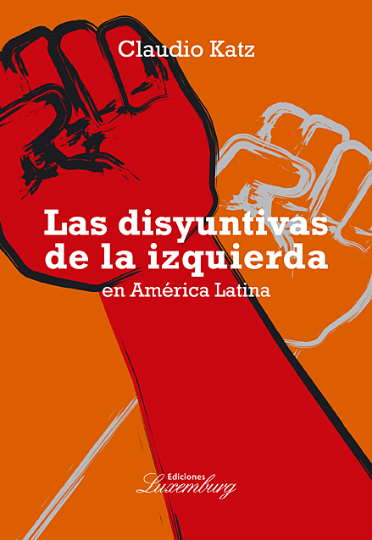
The dilemmas of the left in Latin America
Review of the new book of Claudio Katz
Luxemburg editions,
Buenos Aires, 2008,
270 pages

What political lessons can we learn from the recent popular rebellions in Latin America? Could they lead the way towards socialism? What strategies does the left implements? Launching from these questions the author considers the regional scene by means of historical comparisons, resistances with other zones, and evaluations of the new governments.
Katz combines reflections on the present time with revisions of the classic subjects of rupture and revolution, evaluating the correlation of forces and the level of the popular conscience. He investigates the crisis of neo-liberalism and the decrease of the North American influence in the recent situation of exporting bonanza and increase of the inequality. He locates these characterizations in the five parts of the text, in the controversies that at the moment provoke the different projects from social emancipation.
The book presents an original view on the Latin American left. It illustrates its new force next to the renaissance of the anti-liberal conscience (rejection of the privatizations and free- trade) and the resurgence of an anti-imperialism without regressive ethnic or religious components. The author claims that the neoliberal offensive did not manage to break the political identities of the opressed ones and has coexisted with new advances in the field of democratic liberties.
With this approach, the author compares the recent rebellions of South America with the great revolutions of XX century. He emphasizes that the unanimity of the right wing of the 90s has been replaced by a combination of conservative governments (Uribe, Calderón), moderate leftists (Lula, Kirchner) and radical nationalists (Chávez, Morales). Katz sets up this classification, in opposition to the conventional contrast between Republican administrations and Populists, evoking that presidencialism and clientelism do not constitute exclusive patrimonies of any regime.
The main concern of the author is the future of radical nationalistic experiences. He also considers several negative scenarios (a coup detat, electoral return of the right, stabilization of the state Capitalism) and inverse outcomes of socialist radicalization, in the footpath inaugurated by the Cuban revolution.
For Katz the anti-capitalist processes constitute open options for an entire epoca, which can debut at different moments of the economic cycle. He recognizes that the visibility of the socialist model has decayed, but relativizes the effects of the setback of the USSR on regional left and assigns great importance to the survival of the Cuban revolution.
The author argues with the strategy of stages that postulates a pass through a period of regulated Capitalism before arriving to socialism. He affirms that that direction prevents obtaining significant popular improvements and leads to the disburse of public funds and the expansion of dominant classes. He applies these characterizations to the context of Venezuela and Bolivia and analyzes the concept of “governments in dispute” in Brazil and Argentina.
The book includes several discussions of increasing interest. In the debate of the proposal “to change the world without taking the power” he emphasizes the impossibility of eluding to state action, emphasizing the gravitation of popular demands to this institution. In the controversy with reformism he indicates that the improvements are feasible, but they are not accumulative nor are they irreversible and once they have exceeded a certain limit, they lead to serious confrontations with the dominant classes. In the controversy with the dogmatism he criticizes the simplification of the crisis and the absence of mediations to reach anti-capitalist objectives.
Katz also analyzes the problem of democracy in confrontation with elitist interpretations - that justify citizen´s apathy- and in debate with the institutional approaches that advocate an ingenuous extension of the civic or political improvements to the social arena. He considers that citizen participation is insufficient to incline the operation of the constitutional system in favor of the popular interests and evaluates specifically the participative experience of Porto Alegre. He postulates to construct a socialist democracy differentiated from the bureaucratic totalitarianism and beginning from the Soviet experience he argues in favor of the socialist pluripartidism.
Finally the author approaches the thorny problem of the revolution in a counterpoint with the gradualists’ theories. He evaluates the unfinished processes of XIX century and the combination of Latin America’s conquests and frustrations recorded in the last century. Katz outlines several hypotheses for the future, affirming that the constitutional regimes have modified the times and gestation of popular power. He emphasizes how the action could be integrated in institutional trenches with a anti-capitalist policy.
The book complements the reflections on the post-capitalist society that the author exposed in "El porvenir del socialismo" (2004) and the theses on the regional integration that he developed in “El rediseño de América Latina” (2006).
Claudio Katz is an economist, researcher of the CONICET and professor at the University of Buenos Aires. He has contributed numerous texts to the interpretation of contemporary Capitalism and the Latin American reality and actively participates in the continental forums in opposition to free-trade, the external indebtedness and the militarization. As member of the EDI (Economists of Left) he has published, in addition, several essays on the political and social conjuncture of Argentina. Its new work on ‘The dilemmas of the left in Latin America” constitutes another important achievement of its theoretical elaboration.

Jorge Marchini (Economist and UBA professor)

